
Manor Restaurant Mania!
In Support of Manor and the Spring Social
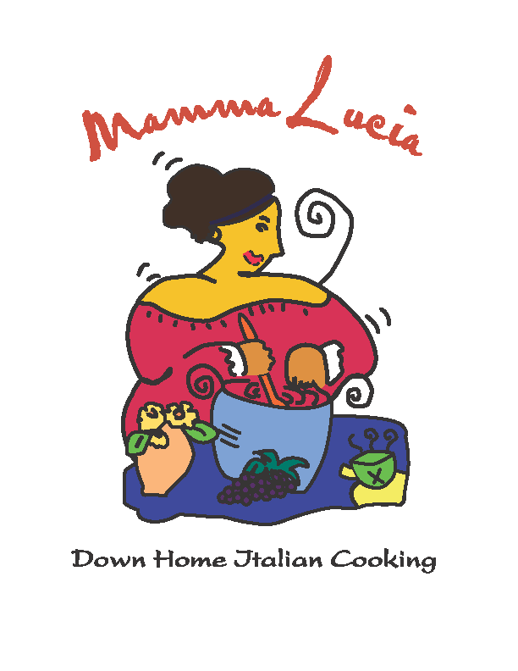

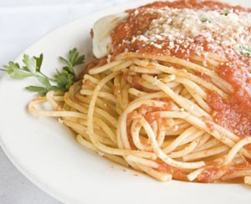
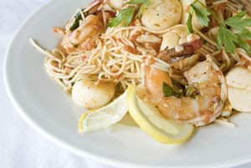

Eat at Mamma Lucia and support
Manor Montessori!
Date: Wednesday, March 28, 2012
Mamma Lucia Fallsgrove,
14921-J Shady Grove Rd.
Rockville - Fallsgrove, MD 20850
301-762-8805
5-10 pm, dine-in or carryout
You MUST present a copy of this flyer, and our school will receive a percentage of the total of all purchases made by Manor guests between 5-10 pm on March 28th.
Tell your friends! And eat some great food - without having to cook!
New Mamma Lucia policy: You must present this FLYER in order to support Manor!!!!

