
Manor Restaurant Mania!
In Support of Manor and the Spring Social

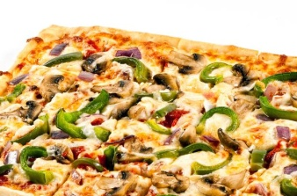
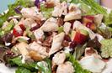


Eat at Ledo Pizza and support
Manor Montessori!
Date: Wednesday, March 14, 2012
10301 Westlake Dr. (behind Montgomery Mall)
Bethesda, MD 20817
301-469-6700
5-9 pm, dine-in or carryout

Mention Manor or present a copy of this flyer, and our school will receive 20% of the total of all purchases made between 5-9 pm on March 14th.
Tell your friends! And eat some great food - without having to cook!
Remember to mention Manor when ordering!!!!!

