
Manor Restaurant Mania!
In Support of Manor and the Spring Social

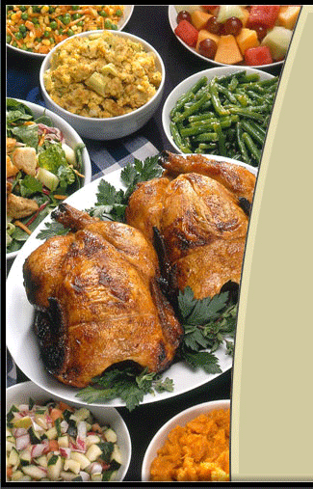



Eat at Chicken Out and support
Manor Montessori!
Date: Wednesday, February 29, 2012
POTOMAC VILLAGE, 10116-B River Road,
Potomac, MD 20854
301-299-8585
11am - 9 pm

Mention Manor or present a copy of this flyer, and our school will receive 20% of the total of all purchases made by Manor guests between 11am - 9 pm on February 29th.
Tell your friends! And eat some great food - without having to cook!
Remember to mention Manor when ordering!!!!!

